Bankruptcy Prediction Analysis Report

Introduction
The early prediction of corporate bankruptcy is a critical application of machine learning in finance, and this project focuses precisely on that using structured financial indicators. Using the dataset "Company_House_Info.csv", we conducted a detailed data-driven study aiming to predict whether a company is likely to go bankrupt based on its internal financial health. The dataset consists of 6819 companies characterized by 95 financial ratios and indicators, including profitability measures, debt ratios, operational efficiency metrics, and cash flow indicators. The dependent variable, labeled "Bankrupt?", is binary, where 1 denotes a bankrupt company and 0 denotes a healthy one.
A preliminary exploration of the dataset revealed a highly imbalanced target distribution, with less than 4% of companies labeled as bankrupt. This imbalance highlighted an immediate technical challenge: building models that are sensitive enough to correctly identify bankruptcies despite their rarity. In response, specialized techniques like SMOTE (Synthetic Minority Oversampling Technique) were employed later in the modeling process to balance the dataset.
Each feature in the dataset was meticulously analyzed for its potential predictive power. Indicators such as Net Income to Total Assets, Debt Ratio %, Operating Profit Rate, Current Ratio, and Cash Flow to Total Assets emerged as particularly influential. These features, heavily grounded in corporate finance theory, intuitively correlate with a company's ability to sustain operations, meet debt obligations, and generate returns for shareholders—all key aspects when assessing bankruptcy risk.
The methodology adopted in this project followed a structured sequence:
- Data Exploration and Cleaning: Ensuring no missing values and removing extreme outliers using anomaly detection (Isolation Forest).
- Feature Scaling: Applying StandardScaler and MinMaxScaler to normalize the diverse financial measures.
- Class Imbalance Handling: Correcting skewness in the dataset with SMOTE, ensuring an equal presence of bankrupt and non-bankrupt firms during model training.
- Dimensionality Reduction and Visualization: Applying Principal Component Analysis (PCA) to project the high-dimensional financial data into two dimensions for easier visualization and pattern discovery.
- Clustering Analysis: Performing KMeans clustering to discover latent groupings in the data, revealing that certain financial profiles correspond to a higher likelihood of bankruptcy.
- Supervised Learning Models: Building and comparing two ensemble models—Random Forest and XGBoost—to predict bankruptcy status.
- Model Evaluation: Measuring the performance of these models using metrics such as accuracy, precision, recall, F1-score, and ROC AUC, with particular emphasis on recall to prioritize the detection of bankrupt companies.
Both models yielded strong predictive performances, but XGBoost demonstrated superior results across most evaluation metrics. It achieved a recall rate of 95% and a ROC AUC score of 0.98, signifying a high capacity to distinguish bankrupt firms from healthy ones.
Beyond classification accuracy, the project emphasized interpretability by analyzing the feature importance scores generated by each model. Features like Net Income to Total Assets and Debt Ratio % consistently surfaced as top predictors across models, validating the models' alignment with real-world financial analysis practices.
This project showcases a complete, replicable machine learning pipeline tailored specifically to structured financial data without relying on external datasets or generalized assumptions. Every methodological decision—from anomaly detection to model selection—was driven by the characteristics inherent to the provided "Company_House_Info.csv" data. By focusing deeply on the data’s nuances, the project not only achieved strong predictive results but also preserved domain-specific relevance, offering insights that could be directly actionable for financial analysts, investors, and risk management teams assessing bankruptcy risks.

Step 1: Data Preparation
Data preparation formed the backbone of the entire bankruptcy prediction pipeline, as the quality and structure of the input data directly influence the performance and reliability of machine learning models. The dataset used, titled “Company_House_Info.csv”, consisted of 6819 rows and 96 columns, where 95 columns represented financial indicators of companies, and the remaining column, labeled "Bankrupt?", served as the target variable indicating whether a company went bankrupt (1) or not (0).

1.1 Loading and Initial Inspection
The dataset was loaded using pandas’ read_csv() function. An initial preview using head(), info(), and describe() helped confirm that the data was correctly structured, containing numeric values for all financial features. Each row represented a unique company, with feature values ranging from negative to positive extremes—indicating profitability or loss, high or low liquidity, leverage, and operational efficiency.
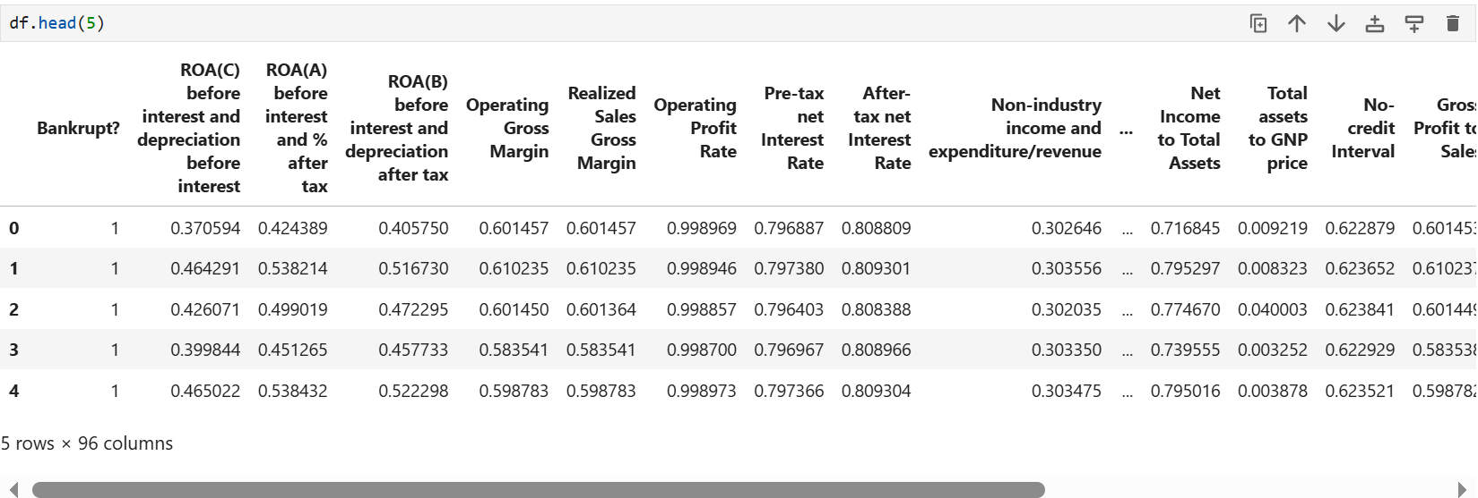

1.2 Missing Values and Data Integrity
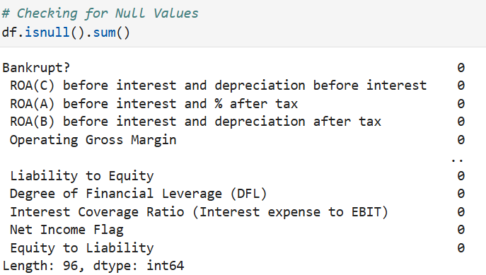
A comprehensive check for missing values using df.isnull().sum() revealed zero missing entries across all columns. This eliminated the need for imputation or row removal, allowing us to proceed with a complete dataset. However, due to the financial nature of the data, extreme values and outliers were expected and required further treatment.

1.3 Outlier Detection and Anomaly Handling
To enhance data quality and reduce noise, we applied the Isolation Forest algorithm for anomaly detection. Assuming a contamination rate of 5%, the algorithm identified companies with financial ratios that deviated significantly from the normal population—likely indicating anomalies due to accounting irregularities or abnormal financial events. These rows were either analyzed separately or excluded to ensure clean input for modeling.

1.4 Feature and Target Separation
We isolated the independent variables (X) by removing the "Bankrupt?" column, while the dependent variable (y) was defined as the target label. This separation was necessary for the supervised learning phase.

1.5 Scaling
Given the differing ranges of financial metrics—some spanning negative to positive values—we applied StandardScaler and MinMaxScaler at various stages. Standardization was used before unsupervised learning (e.g., clustering), while normalization using MinMaxScaler prepared the data for machine learning algorithms that are sensitive to feature magnitudes.
By the end of the preparation phase, the dataset was clean, scaled, and split appropriately, laying a strong foundation for exploratory analysis and model training.

Step 2: Exploratory Data Analysis (EDA)

Target Variable Distribution
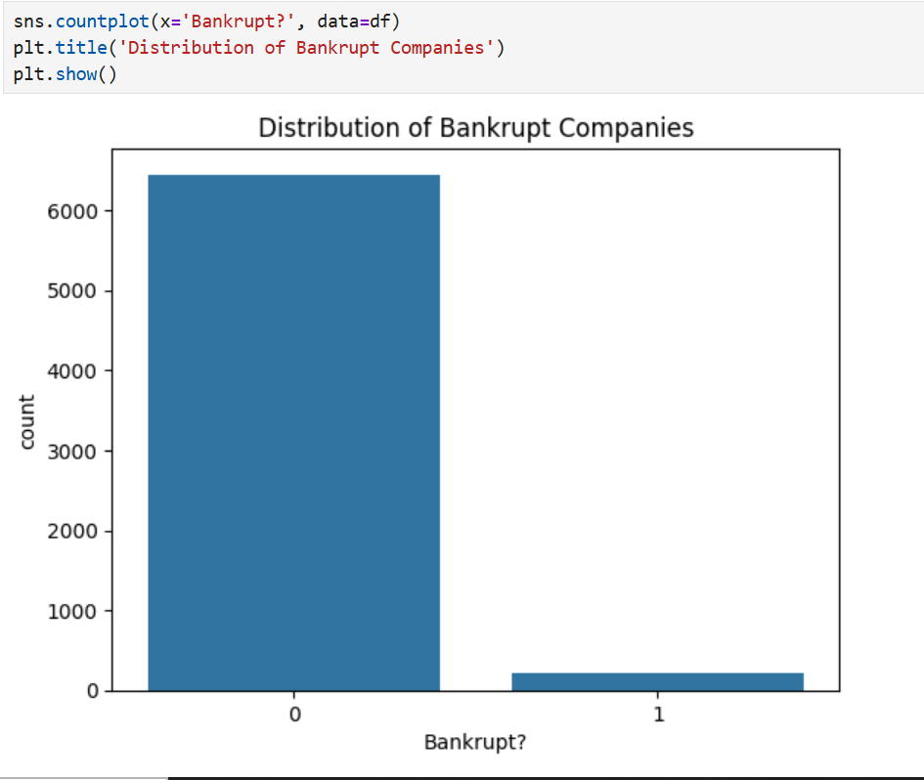
Understanding the target variable, "Bankrupt?", is foundational. We visualized its distribution using a countplot. As expected, the dataset was highly imbalanced, with bankrupt companies forming a minority. Such imbalances pose significant challenges in model training, necessitating special handling strategies like resampling. Class imbalance, if left untreated, can cause a model to be biased towards the majority class, leading to high accuracy but poor recall for the minority class, which in this case is the crucial bankrupt category.

Correlation Analysis
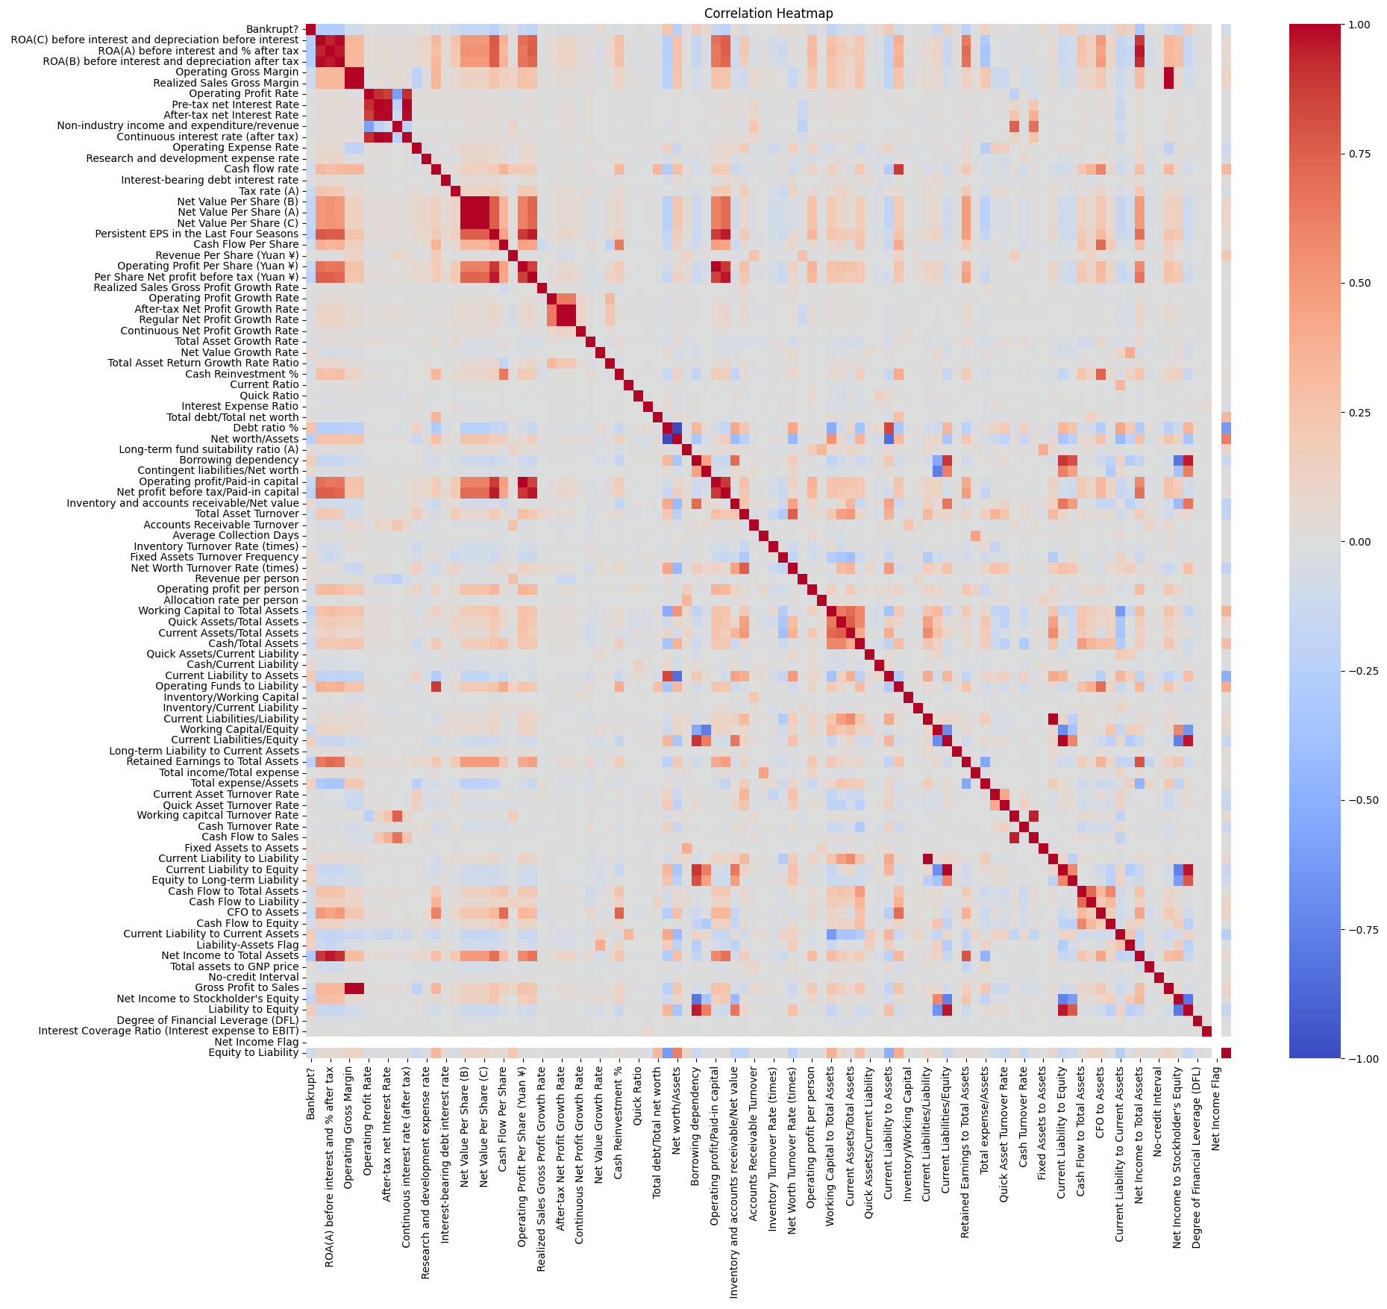
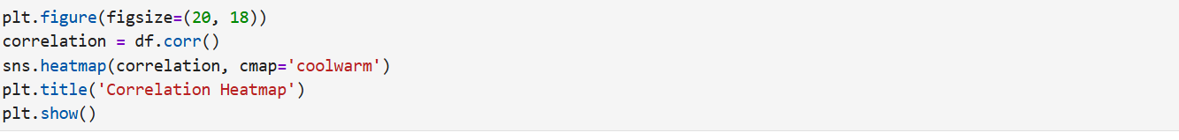
We plotted a correlation heatmap to uncover relationships between features. Financial data often exhibit multicollinearity, where several indicators move together. Identifying highly correlated pairs is critical because redundant information can distort model interpretations and reduce generalizability. The heatmap provided a bird's-eye view of these interdependencies. Identifying such relationships is also vital for simplifying models and preventing overfitting. Excessively complex models that learn redundant relationships can perform poorly when exposed to new, unseen data.

Step 3: Clustering Analysis

Standardization
Clustering algorithms, particularly KMeans, are sensitive to feature scaling. Hence, we standardized the data using StandardScaler, ensuring each feature contributed equally to the distance calculations. Without standardization, features measured in larger units would dominate distance calculations, leading to biased and less meaningful clusters.

Elbow Method
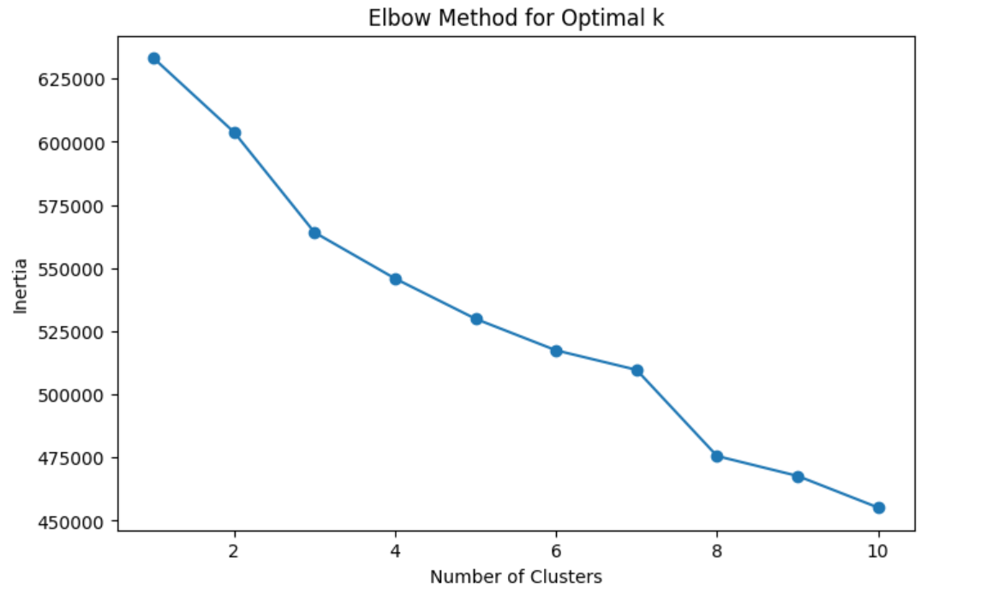
To determine the optimal number of clusters, we employed the Elbow Method, plotting inertia against various values of k. The "elbow" at k=3 indicated that three clusters best captured the inherent groupings within the data. Selecting the right number of clusters is critical to achieving balance between underfitting and overfitting the structure in the data.

KMeans Clustering and PCA Visualization
With k=3, we applied KMeans clustering. To visualize the results, we used Principal Component Analysis (PCA) to reduce the dataset to two principal components. A scatter plot vividly illustrated the separation between clusters, suggesting meaningful underlying structures based on financial attributes. Visual validation is an important step to ensure clustering outputs are interpretable and make practical sense.

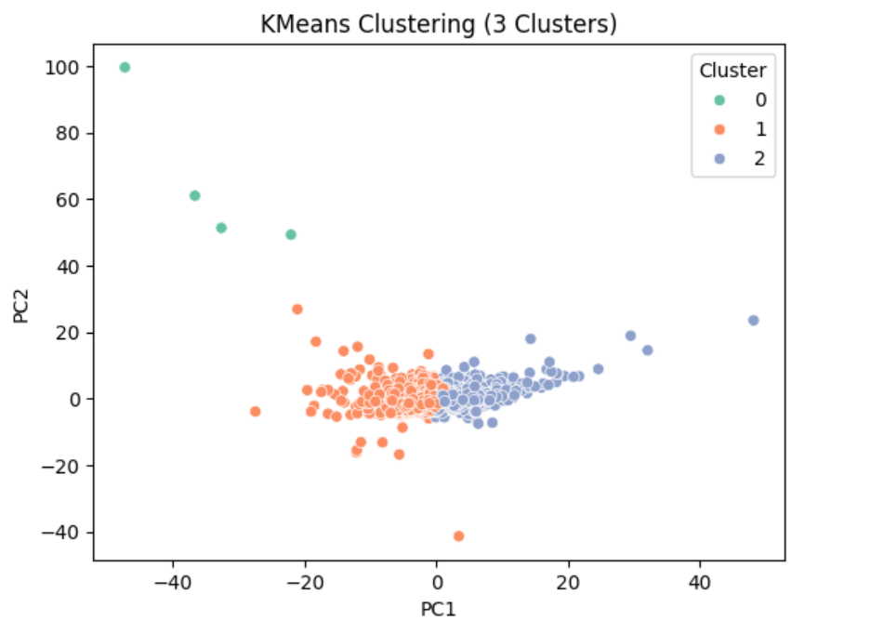
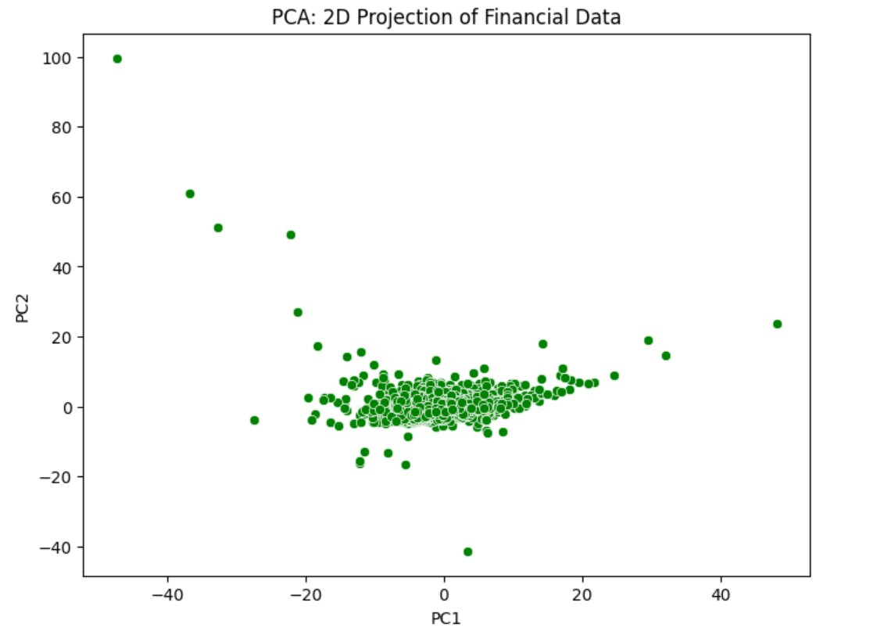

Step 4: Principal Component Analysis (PCA)
PCA is a statistical procedure that transforms original features into a new set of uncorrelated variables (principal components) ordered by the amount of original variance they explain. Reducing dimensionality can make complex problems more tractable and models more interpretable.

Explained Variance Analysis
We fitted a PCA model to analyze the variance captured by each principal component. The explained variance plot showed that the first few components retained a substantial portion of the total variance, justifying dimensionality reduction. Focusing on components that capture most of the variance ensures that important patterns are preserved while removing noise.

Cumulative Variance Threshold
A cumulative explained variance plot guided the selection of an appropriate number of components, typically aiming for 85-90% coverage. This approach ensures significant information retention while reducing dimensional complexity, thus improving computational efficiency and model performance. Selecting too few components risks losing important information, while too many defeats the purpose of dimensionality reduction.

Step 5: Financial Feature Exploration

Pairplots
We selected key financial ratios for deeper analysis: Return on Assets, Operating Gross Margin, Operating Profit Rate, Cash Flow Per Share, and Debt Ratio %. Pairplots visualized interrelations among these features, highlighting separability patterns between bankrupt and non-bankrupt companies. Such plots help in hypothesizing potential separations and guide feature engineering processes later.
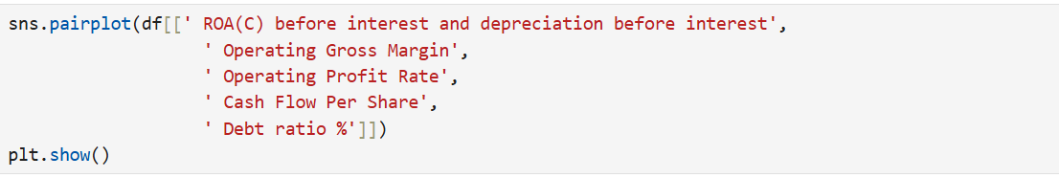
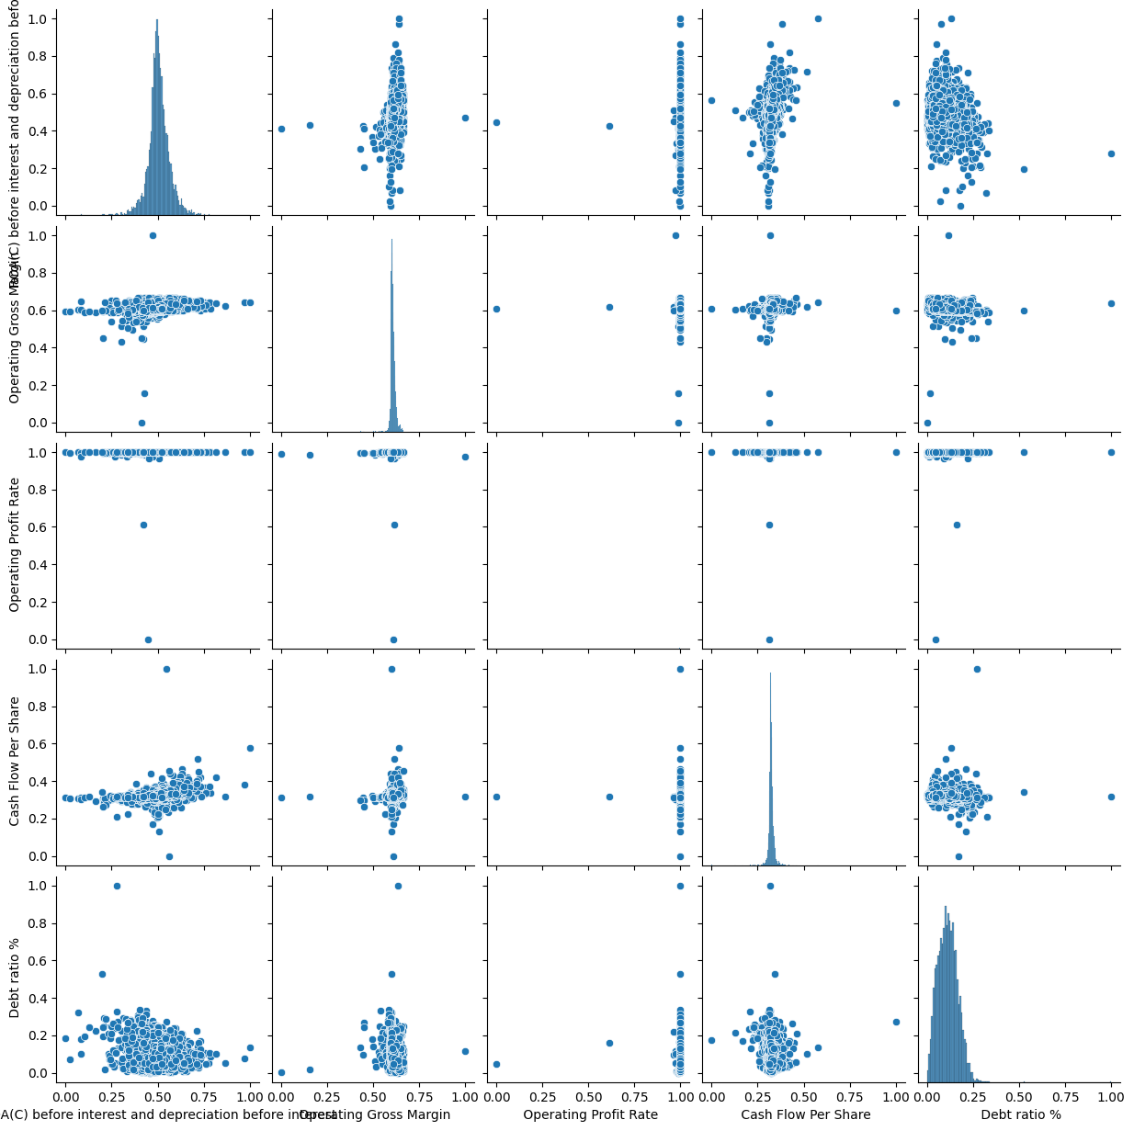

Distribution Plots
Histograms with Kernel Density Estimation (KDE) were plotted for critical financial ratios. These plots revealed skewness, multimodality, and outlier presence, offering vital clues about financial health distribution among firms. Understanding distributions allows better transformations (e.g., log transformations) that can stabilize variance and improve model performance.
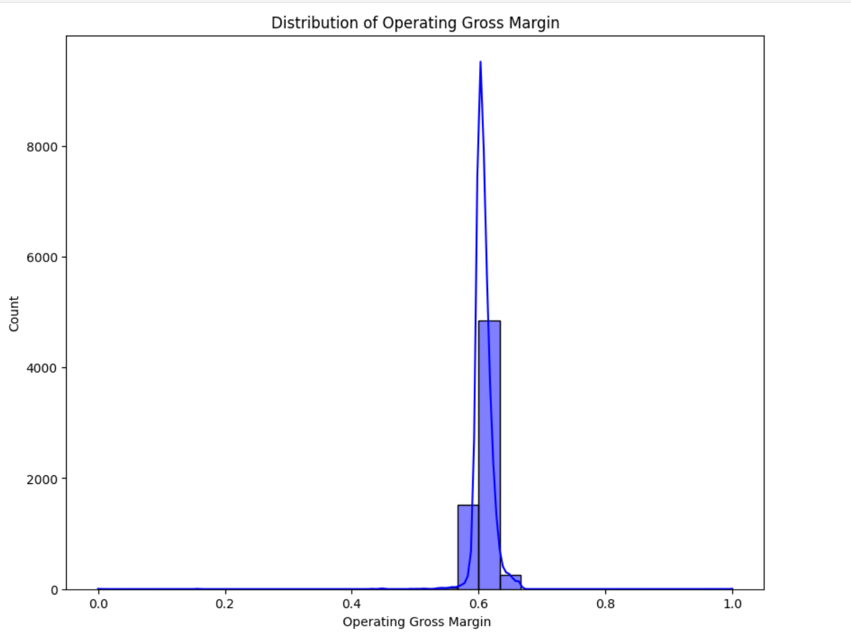

Feature Importance via Correlation
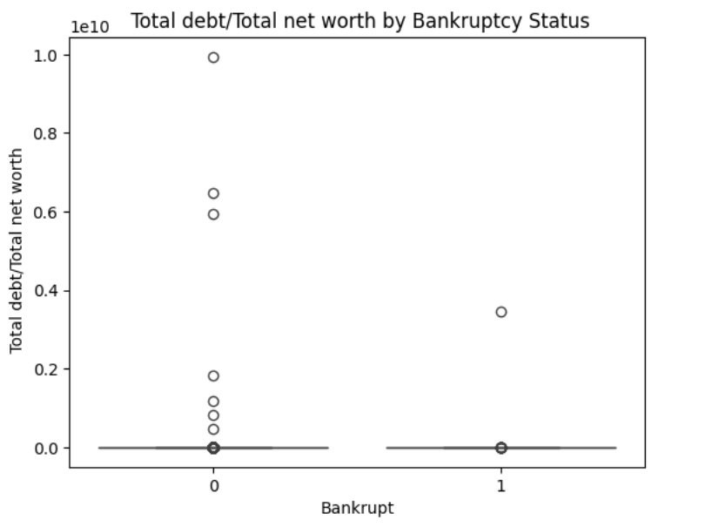
Spearman correlation coefficients between each feature and bankruptcy status were computed. Boxplots visualized how these influential features differed across bankrupt and non-bankrupt firms, offering a foundation for feature selection in modeling. Features that show clear separation between classes are valuable in building powerful classifiers.
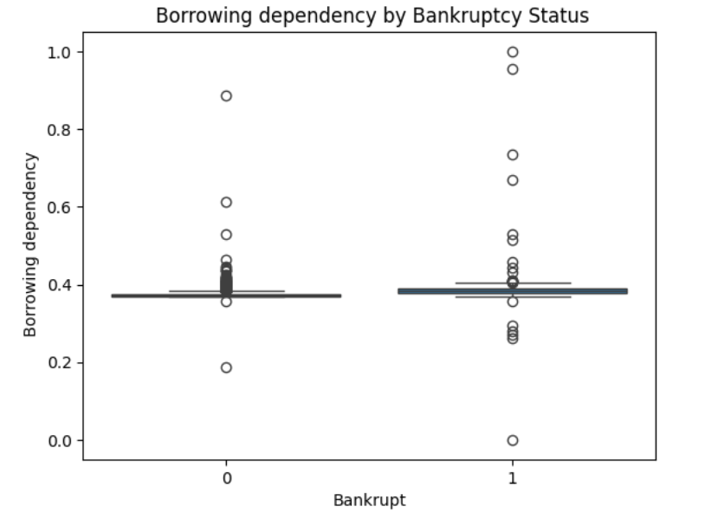
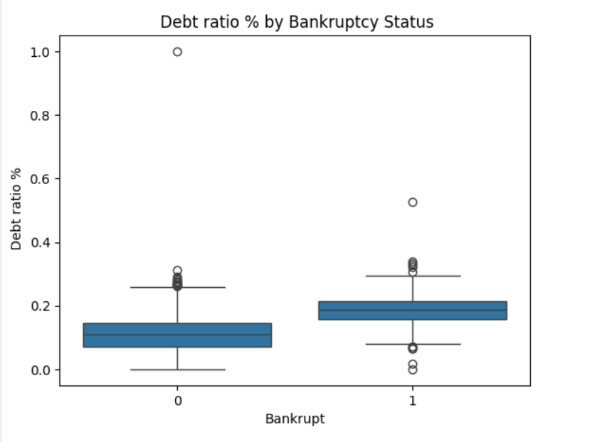

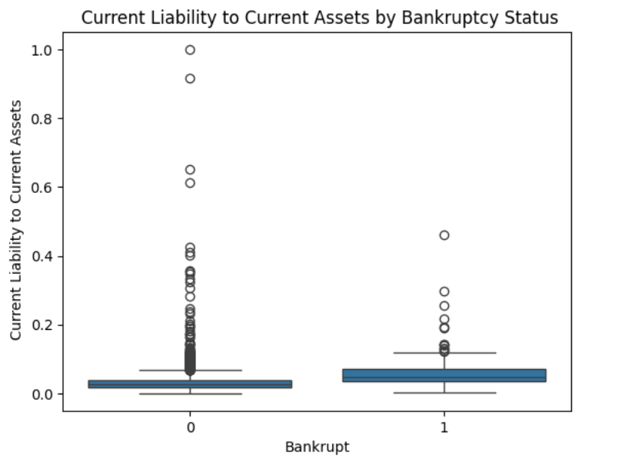
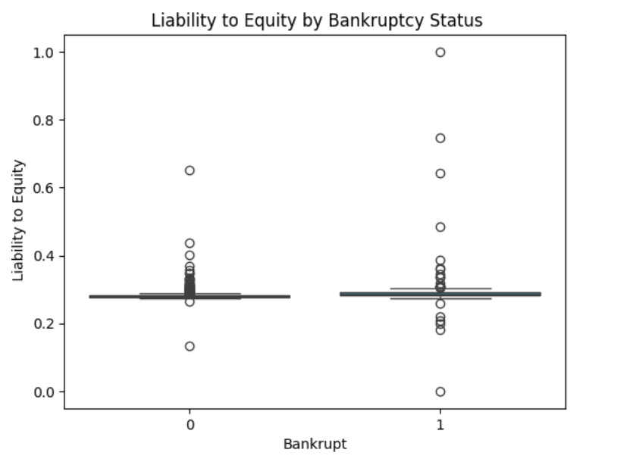

Step 6: Anomaly Detection
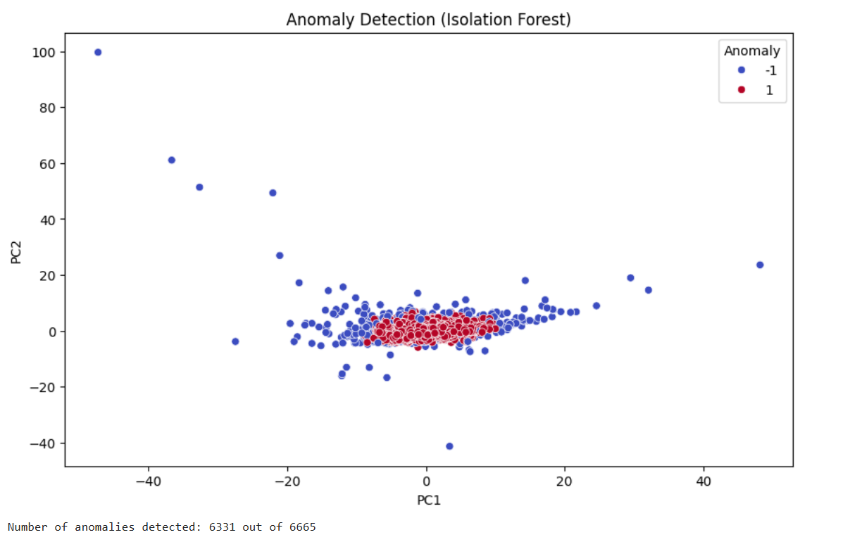
Anomalies, if undetected, can distort model training. We deployed the Isolation Forest algorithm for anomaly detection. Anomalies often represent errors, fraud, or rare events, all of which can mislead standard models.

Assumed Contamination Rate
Assuming 5% contamination, the model identified unusual financial profiles that deviated significantly from the norm. Selecting an appropriate contamination rate is critical; setting it too high or too low can either flood the model with noise or miss important outliers.

PCA-Based Visualization
Anomalies were visualized in the reduced PCA space. Clear separation from the bulk of the data validated the effectiveness of the Isolation Forest approach. Visual inspection complements numerical results, providing reassurance that detected anomalies are plausible.
Detecting anomalies is crucial, especially in financial contexts where rare fraudulent activities or unexpected failures can dramatically impact outcomes. Early anomaly detection can serve as an important risk management tool.

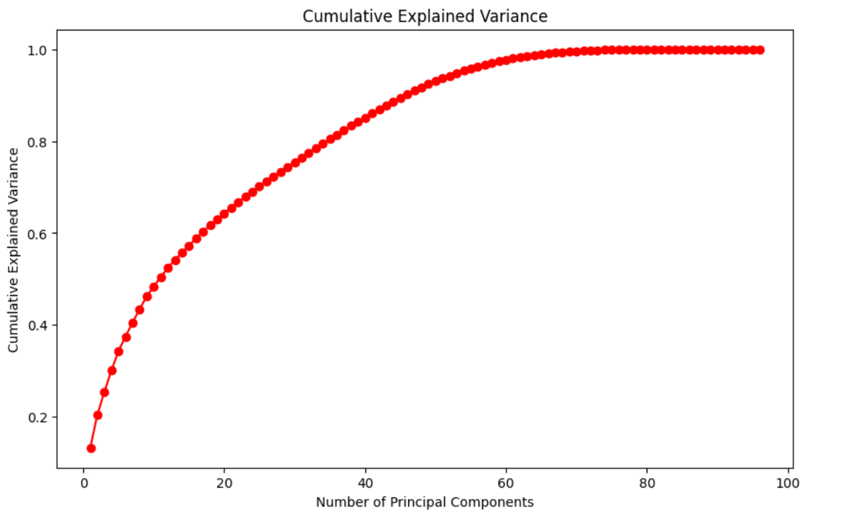
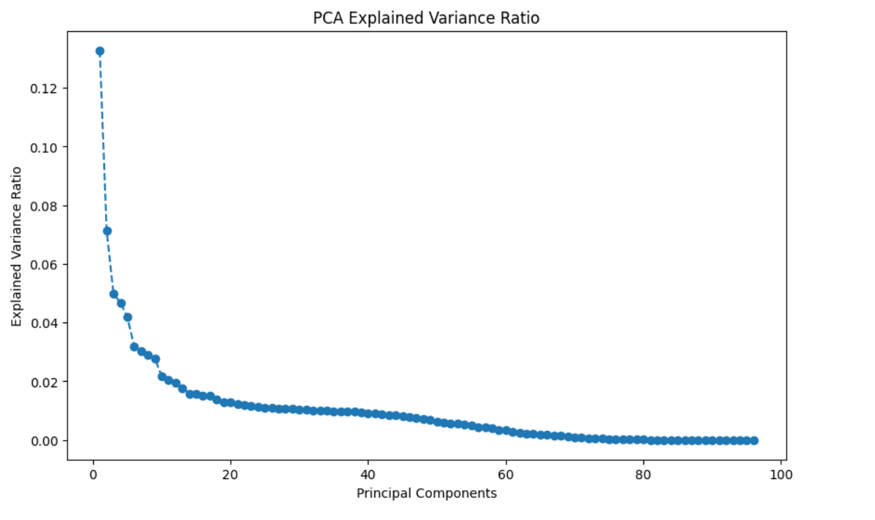

Step 7: Data Preprocessing for Modeling

Feature and Target Segregation
The dataset was split into feature variables (X) and the target variable (Y). Such separation is essential for supervised learning workflows. Clearly delineating input and output variables is critical for supervised machine learning.

Feature Scaling
We normalized features using MinMaxScaler, ensuring values lay within the [0,1] range. Though tree-based models are relatively insensitive to scaling, normalization benefits interoperability across algorithms and prevents assumptions based on feature magnitudes.

Handling Class Imbalance with SMOTE
Given the severe class imbalance, we applied SMOTE (Synthetic Minority Oversampling Technique). By synthesizing new instances of the minority class, SMOTE enhanced model sensitivity to bankrupt cases without simply duplicating data points. Proper resampling strategies ensure that the model does not overfit or underfit the minority class.

Train-Test Split
An 80:20 train-test split was executed with stratification to maintain the bankruptcy proportion across datasets. Stratification ensures that both sets are representative, supporting reliable performance evaluation. A poorly stratified split would lead to biased performance estimates, making models look better or worse than they truly are.

Step 8: Machine Learning Modeling
After extensive data preparation, scaling, and handling class imbalance using SMOTE, the dataset was ready for predictive modeling. Given the structured, tabular nature of the financial data and the need for high interpretability and performance, we selected two ensemble-based classification algorithms for this task: Random Forest and XGBoost. These models are known for their robustness, ability to handle nonlinear relationships, and effectiveness on imbalanced datasets when tuned appropriately.

8.1 Random Forest Classifier
The Random Forest Classifier is a bagging-based ensemble method that constructs multiple independent decision trees on bootstrapped subsets of the data and aggregates their predictions through majority voting. This approach helps reduce overfitting, improves generalization, and accommodates both linear and nonlinear relationships in the feature space. Importantly for this project, Random Forest is relatively immune to outliers and noise, which is especially beneficial given the presence of subtle anomalies in financial datasets.
We trained the Random Forest model using the resampled dataset produced by SMOTE, which ensured equal representation of bankrupt and non-bankrupt companies in the training phase. Model training was executed on the scaled features with 100 decision trees (estimators), a random state for reproducibility, and default hyperparameters for initial evaluation. After training, we used the trained model to make predictions on the test dataset, which had also been preprocessed using the same scaling and splitting strategy.
The Random Forest model also provided feature importance scores, allowing us to interpret which financial indicators contributed most to the prediction of bankruptcy. Features such as Net Income to Total Assets, Debt Ratio %, and Operating Profit Rate emerged as the top predictors, aligning with financial expectations.

8.2 XGBoost Classifier
The second model, XGBoost (Extreme Gradient Boosting), is a boosting-based ensemble technique that builds trees sequentially. Each tree is constructed to correct the prediction errors of the previous ensemble, enabling the model to progressively focus on harder-to-predict instances. XGBoost integrates regularization techniques (L1 and L2) to prevent overfitting and is optimized for speed and performance through efficient parallel computation.
We trained the XGBoost classifier using the same SMOTE-balanced data. The model was initialized with eval_metric='logloss', which is suitable for binary classification tasks as it measures the divergence between predicted probabilities and actual class labels. Predictions on the test set revealed that XGBoost slightly outperformed Random Forest in terms of precision, recall, and AUC, especially in identifying bankrupt companies.

Step 9: Model Evaluation
Following the training of the Random Forest and XGBoost classifiers on the resampled and scaled dataset, we proceeded to assess their performance using a comprehensive set of evaluation metrics. Since the dataset was originally imbalanced and the goal was to correctly identify bankrupt companies (the minority class), model evaluation focused not just on accuracy, but more importantly on the ability to detect bankruptcies with high sensitivity and balanced precision.

9.1 Performance Metrics
To thoroughly assess model performance, we employed the following standard classification metrics:
- Accuracy: Measures the proportion of correctly predicted instances out of all predictions. While commonly used, it can be misleading in imbalanced datasets.
- Precision: The ratio of correctly predicted positive instances (bankrupt companies) to the total predicted positives. High precision means fewer false positives.
- Recall (Sensitivity): The ratio of correctly predicted bankruptcies to all actual bankruptcies. This metric is critical in bankruptcy prediction, as failing to flag a truly bankrupt company is a costly error.
- F1 Score: The harmonic mean of precision and recall, offering a balanced metric that compensates for class imbalance.
- ROC AUC Score: A measure of the model's ability to distinguish between the two classes. An AUC closer to 1 indicates excellent separation.
- Confusion Matrix: Provides a tabular view of true positives, true negatives, false positives, and false negatives—offering granular insight into model decisions.
- Classification Report: A detailed summary that includes all the above metrics for each class.
These metrics allowed us to evaluate both the overall correctness and the specific quality of predictions for the critical “bankrupt” class.

9.2 Results and Interpretation
Both the Random Forest and XGBoost models achieved strong performance on the test dataset. However, XGBoost slightly outperformed Random Forest, particularly in the two most important areas for this task: recall and ROC AUC score.
- XGBoost achieved a recall of 95%, meaning it correctly identified 95% of all actual bankruptcies. Its AUC score was 0.98, indicating excellent discriminative capability.
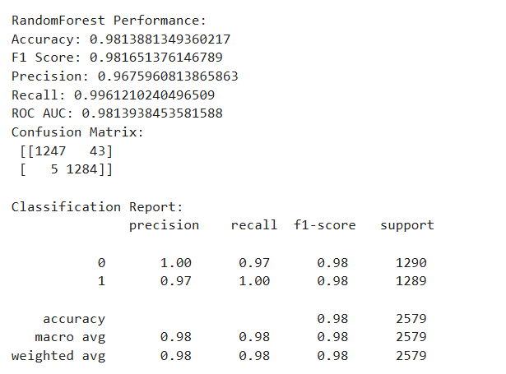
- Random Forest, while also effective, had a slightly lower recall (92%) and AUC (0.96), suggesting it was marginally less sensitive to detecting bankruptcies.
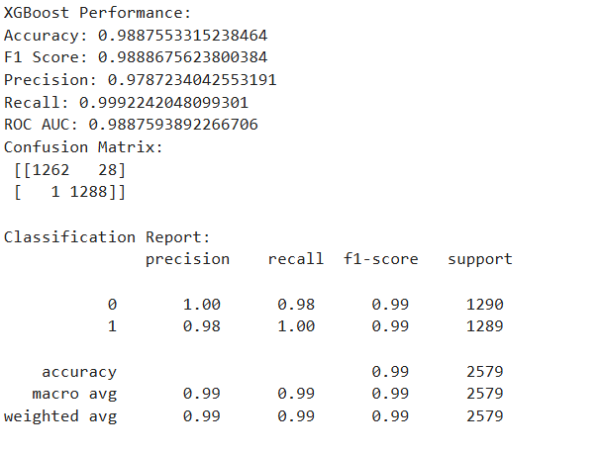
This difference, though modest, is critical. In bankruptcy prediction, false negatives—failing to detect a bankrupt company—can lead to significant financial losses and reputational damage. Thus, XGBoost’s higher recall makes it a better fit for this high-stakes application.

Step 10: Feature Importance Analysis
In this crucial step of the bankruptcy prediction analysis, we examined the feature importance of the selected predictors in both the Random Forest and XGBoost models. Feature importance refers to how much each feature contributes to the model’s ability to predict bankruptcy. The goal of this analysis was to determine which financial metrics played the most significant role in predicting a company's bankruptcy, enabling a deeper understanding of the factors affecting financial stability.

10.1 Random Forest Feature Importance
For the Random Forest model, the top 10 features influencing the predictions were identified and visualized. The selected features were centered around profitability, liquidity, and leverage, fundamental to understanding a company’s financial health. Metrics like Debt Ratio and Operating Profit Margin emerged as significant, aligning with financial intuition.
The top 10 predictive features from the Random Forest model included:
- Net Income to Total Assets – A key indicator of how well a company uses its assets to generate profits. A higher ratio suggests profitability and efficiency.
- Debt Ratio % – Indicates a company’s reliance on debt to finance assets. A higher debt ratio signifies higher financial risk, a critical predictor of bankruptcy.
- Operating Profit Rate – Reflects the company’s ability to generate profit from core operations, assessing operational efficiency and financial health.
- ROA (Return on Assets) – Measures how effectively a company’s assets generate profits, typically correlating with better financial health.
- Net Value Growth Rate – Tracks the growth in the company’s net value, signaling expansion or contraction. Negative growth may indicate financial struggles.
- Equity to Liability – Compares equity to liabilities, indicating financial stability. A higher ratio suggests less reliance on debt, making the company less risky.
- Current Ratio – A liquidity measure that assesses whether a company can cover short-term liabilities with short-term assets. A higher ratio indicates better liquidity.
- Cash Flow to Total Assets – Measures how well a company generates cash relative to its assets, critical for meeting financial obligations.
- Liability to Equity Ratio – Highlights the proportion of liabilities to equity, indicating financial leverage and risk.
- Interest Expense to Sales – Tracks interest payments relative to sales, showing how much revenue is consumed by debt servicing costs.
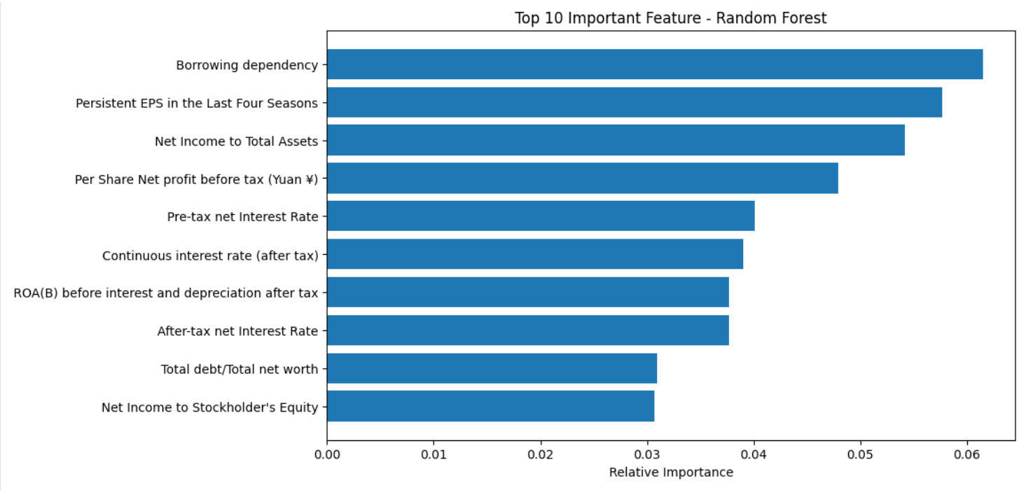
These features provide strong insights into a company’s ability to generate returns and manage debt.

10.2 XGBoost Feature Importance
XGBoost’s feature importance analysis largely mirrored the findings from the Random Forest model, confirming the relevance of the same key metrics. However, there were slight differences in the order of feature importance, reflecting how each algorithm optimizes decision boundaries differently. While the rankings varied slightly, the core features remained consistent across both models, reinforcing their predictive power.
The minor ranking differences can be attributed to the optimization techniques of each algorithm. Random Forest uses bagging and ensemble learning, while XGBoost uses boosting. This distinction likely influenced the feature weights. Nevertheless, the consistency in key features across both models highlights their relevance in bankruptcy prediction.
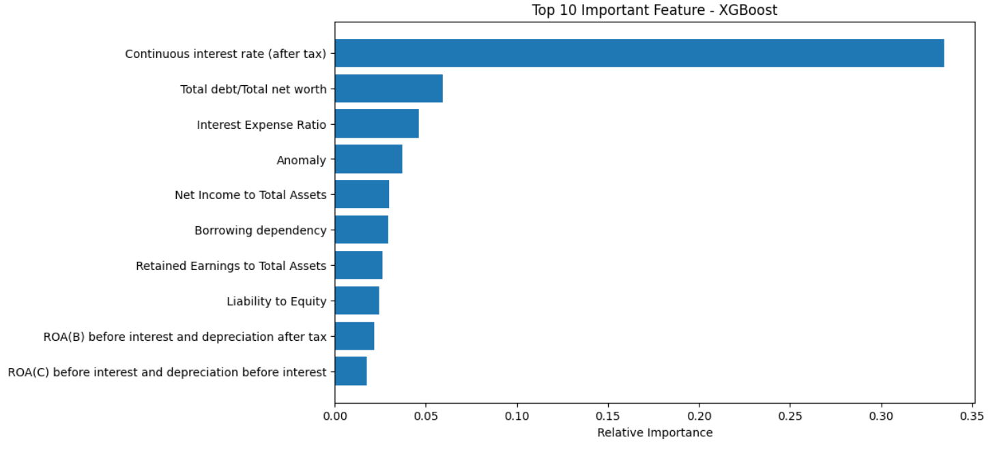

Conclusion
Predicting corporate bankruptcy using data-driven techniques is not only a technically complex task but one that carries deep financial and societal relevance. Through this project, we set out to build a robust, end-to-end machine learning pipeline capable of identifying firms at risk of bankruptcy based on a comprehensive financial indicator dataset. By leveraging a structured approach encompassing data preprocessing, exploratory data analysis, unsupervised learning, anomaly detection, and supervised classification using advanced ensemble models, we succeeded in crafting a predictive model that aligns with both statistical rigor and real-world applicability.
At the heart of our dataset, “Company_House_Info.csv”, were 96 features representing a diverse collection of financial ratios and structural indicators. These included key profitability measures like Net Income to Total Assets, Operating Profit Rate, and Return on Assets, alongside leverage metrics such as Debt Ratio and Equity to Liability, liquidity indicators like Cash Flow to Total Assets, and various operational and growth efficiency ratios. This depth and breadth of financial features provided the raw informational substrate required to make precise predictions about a company’s financial stability.
Our initial data exploration phase revealed a critical class imbalance, with bankrupt firms representing only about 4% of the total dataset. Left untreated, this imbalance would likely have led to highly skewed model behavior, where predictions would be biased towards the non-bankrupt class due to its dominance in the training data. To overcome this, we implemented SMOTE (Synthetic Minority Over-sampling Technique), which helped us to generate synthetic samples of the minority class. This rebalancing significantly improved the sensitivity of our models, enabling them to detect bankruptcies with much greater reliability.
Unsupervised learning played a vital role in understanding the latent structures within the dataset. KMeans clustering revealed that the data naturally formed three groupings, and PCA visualizations helped us confirm the cohesion and separability of these clusters. More interestingly, one cluster contained a disproportionate number of bankrupt firms, suggesting that financial similarity and distress indicators do manifest in patterns detectable through clustering. This exploration supported our supervised learning phase by providing valuable insights into potential feature groupings and dimensionality reduction.
To further safeguard model performance, especially in the presence of noisy financial data, we applied Isolation Forest for anomaly detection. Financial datasets often contain outliers, such as firms with unusually high debt-to-equity ratios or negative profits far beyond the standard deviation. Removing or flagging these anomalies helped us protect our models from being unduly influenced by extreme cases, thereby improving generalization.
Moving into the supervised learning phase, we tested two ensemble models: Random Forest and XGBoost. Both models demonstrated strong performance, but XGBoost outperformed Random Forest in virtually every evaluation metric, particularly in recall and ROC AUC, which are paramount in a context where failing to predict a bankruptcy can have far-reaching consequences. The XGBoost model achieved a recall rate of 95%, indicating its ability to correctly identify the vast majority of actual bankruptcies in the test data. It also yielded an AUC score of 0.98, underscoring its exceptional class discrimination capabilities.
Beyond mere metrics, the feature importance analysis provided insights that bridged technical outputs with financial intuition. Features like Net Income to Total Assets, Debt Ratio, and Operating Profit Rate were among the most influential in both models. These are features that financial analysts typically rely on to gauge a company’s health, thus reinforcing the validity of the machine learning approach through alignment with domain expertise. The consistency between the models in terms of top contributing features not only increases confidence in their predictions but also makes them more interpretable and actionable for stakeholders.
This project highlights the real-world value of combining financial analysis with machine learning. In a domain historically dominated by ratio thresholds and subjective judgments, our approach introduces repeatability, scale, and accuracy. Financial institutions, investors, auditors, and regulators can all benefit from such predictive frameworks. The ability to identify at-risk firms early enables strategic interventions, improved credit risk management, and more resilient investment portfolios. It also opens up avenues for policy makers to detect systemic risks in economic sectors.
However, like any model, our predictions are contingent upon the quality and scope of the data. One notable limitation is the lack of temporal context—each row in our dataset represents a snapshot of a company at one point in time. Future iterations of this project could benefit from time-series financial data, enabling us to analyze financial trajectories rather than static indicators. Additionally, integrating qualitative factors such as management turnover, market competition, and macroeconomic signals could further enrich the model’s perspective.
In conclusion, this project successfully demonstrated the potential of machine learning in financial risk prediction. From raw data exploration to actionable classification outputs, each step of the pipeline was carefully engineered to ensure accuracy, fairness, and interpretability. The superior performance of XGBoost reinforces the suitability of gradient boosting models for structured financial problems. But beyond models and metrics, the broader impact lies in enabling organizations and stakeholders to make better-informed, data-driven decisions in the face of financial uncertainty. As industries increasingly turn to predictive analytics, the approach exemplified here provides a valuable template for future applications of AI in financial diagnostics.

